PART 1 :
(C)

Query 1: Aggregation by Customer City
SELECT
c.cust_city,
SUM(s.amount_sold) AS total_sales,
AVG(s.quantity_sold) AS avg_quantity
FROM
sales s
JOIN customers c ON s.cust_id = c.cust_id
GROUP BY
c.cust_city;
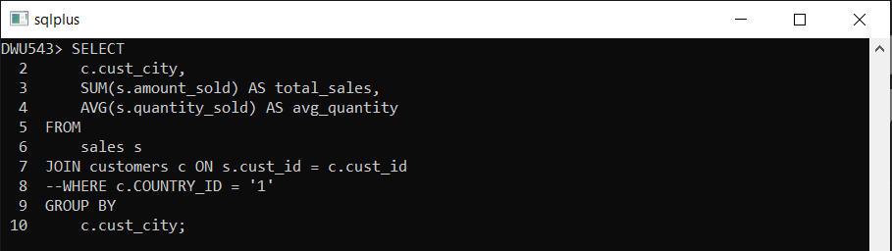

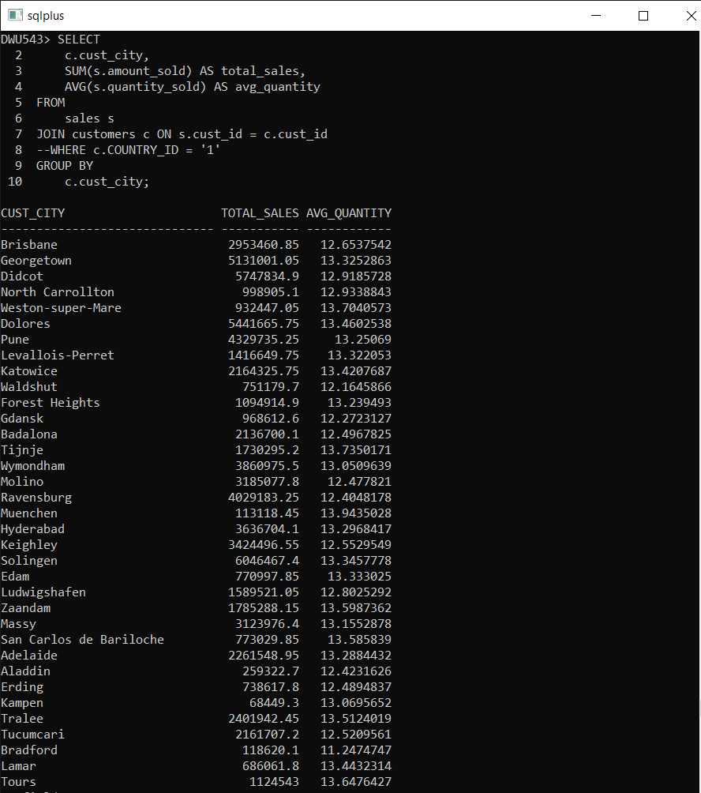

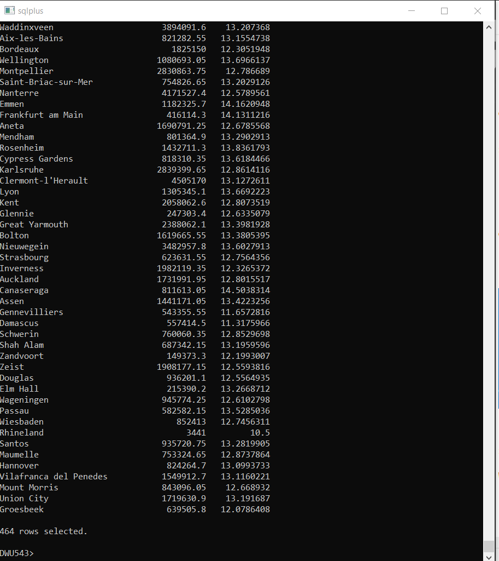

Explanation:
- This query aggregates data by cust_city.
- Useful for analyzing total and average sales at the city level.
Query 2: Aggregation by Product Category
SELECT
p.prod_category,
SUM(s.amount_sold) AS total_sales,
AVG(s.quantity_sold) AS avg_quantity
FROM
sales s
JOIN products p ON s.prod_id = p.prod_id
GROUP BY
p.prod_category;
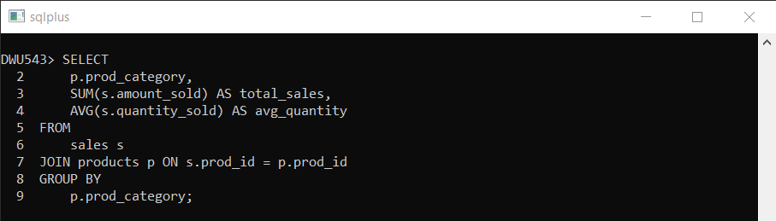
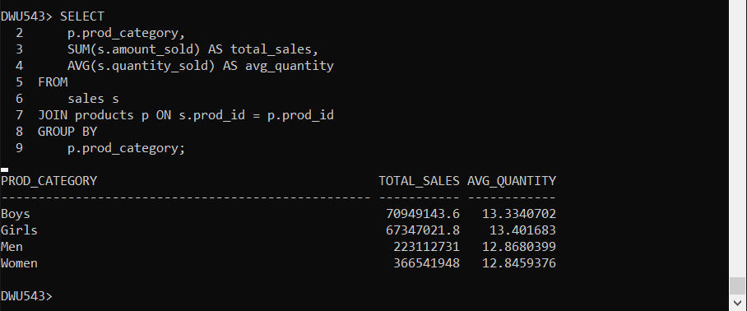
Explanation:
- This query aggregates data by prod_category.
- Useful for analyzing total and average sales by product category.

SQL Query Using CUBE (both queries together in one)

SELECT
c.cust_city,
p.prod_category,
SUM(s.amount_sold) AS total_sales,
AVG(s.quantity_sold) AS avg_quantity
FROM
sales s
JOIN customers c ON s.cust_id = c.cust_id
JOIN products p ON s.prod_id = p.prod_id
GROUP BY CUBE(c.cust_city, p.prod_category);
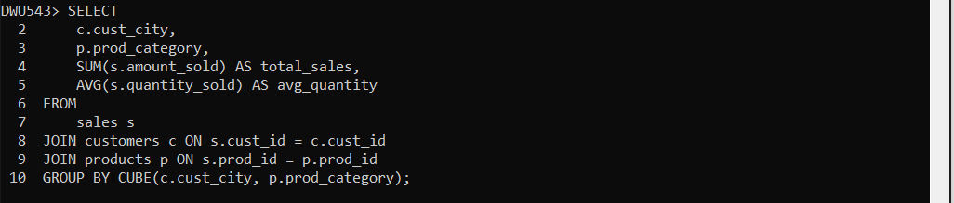

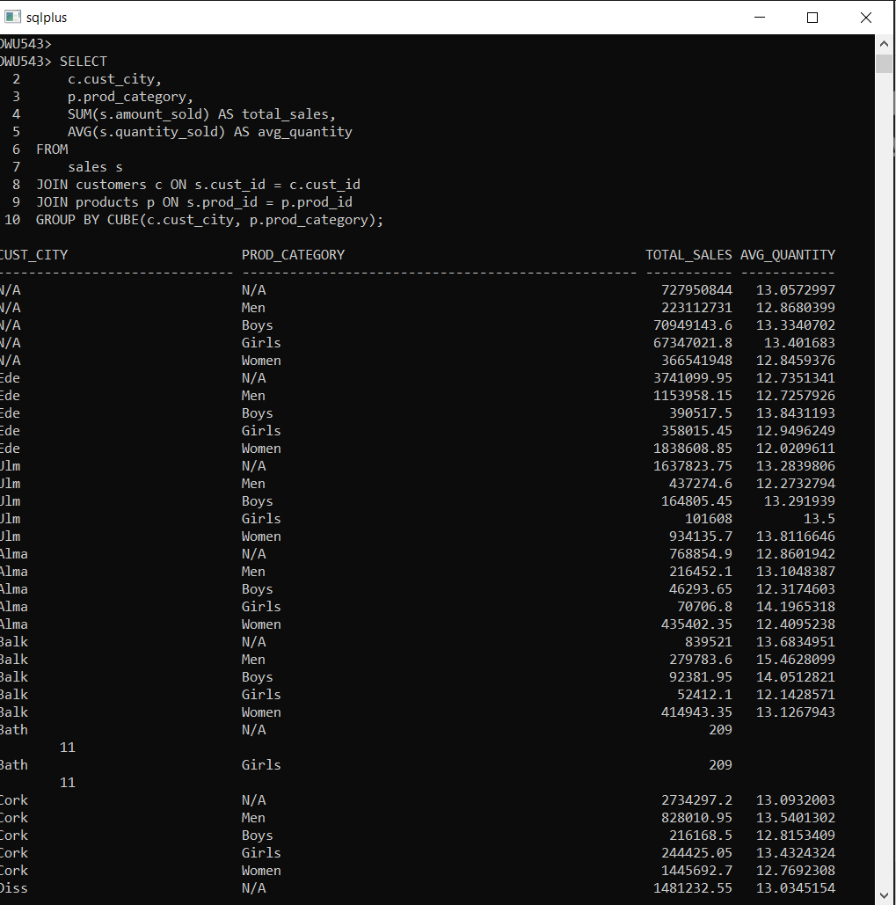s
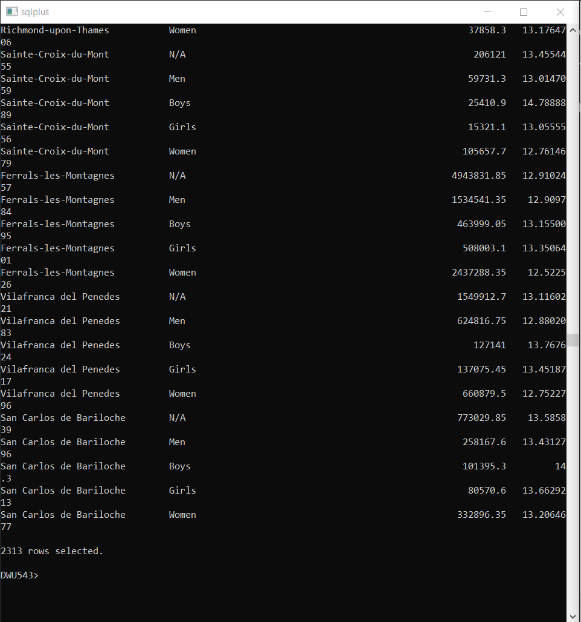

Explanation of the Query
- Fact Table:
SALES: Provides transactional data, including amount_sold and quantity_sold.
- Dimension Tables:
CUSTOMERS: Links transactions to cust_city.
PRODUCTS: Links transactions to prod_category.
- Aggregate Functions:
SUM(s.amount_sold): Calculates total sales for each grouping level.
AVG(s.quantity_sold): Calculates the average quantity sold for each grouping level.
- CUBE Functionality:
GROUP BY CUBE(c.cust_city, p.prod_category) generates aggregations for:
- Individual cust_city and prod_category.
- Combined grouping of cust_city and prod_category.
- Overall totals (grand summary).
- Purpose:
Helps users analyze sales performance at multiple levels: by city, by product category, and a combined view.

Why This Query is Useful
- For Managers:
Identify cities or product categories driving sales.
Compare performance across regions and categories.
- For Marketing Teams:
Design targeted promotions based on city or category performance.
- For Decision-Makers:
Provide a summarized view of total and average sales at various levels, enabling better strategy formulation.

ii)
SQL Query Using UNION ALL

SELECT
c.cust_city,
p.prod_category,
SUM(s.amount_sold) AS total_sales,
AVG(s.quantity_sold) AS avg_quantity
FROM sales s
JOIN customers c ON s.cust_id = c.cust_id
JOIN products p ON s.prod_id = p.prod_id
GROUP BY
c.cust_city, p.prod_category
UNION ALL
SELECT
c.cust_city,
NULL AS prod_category,
SUM(s.amount_sold) AS total_sales,
AVG(s.quantity_sold) AS avg_quantity
FROM sales s
JOIN customers c ON s.cust_id = c.cust_id
GROUP BY
c.cust_city
UNION ALL
SELECT
NULL AS cust_city,
p.prod_category,
SUM(s.amount_sold) AS total_sales,
AVG(s.quantity_sold) AS avg_quantity
FROM sales s
JOIN products p ON s.prod_id = p.prod_id
GROUP BY
p.prod_category
UNION ALL
SELECT
NULL AS cust_city,
NULL AS prod_category,
SUM(s.amount_sold) AS total_sales,
AVG(s.quantity_sold) AS avg_quantity
FROM sales s;



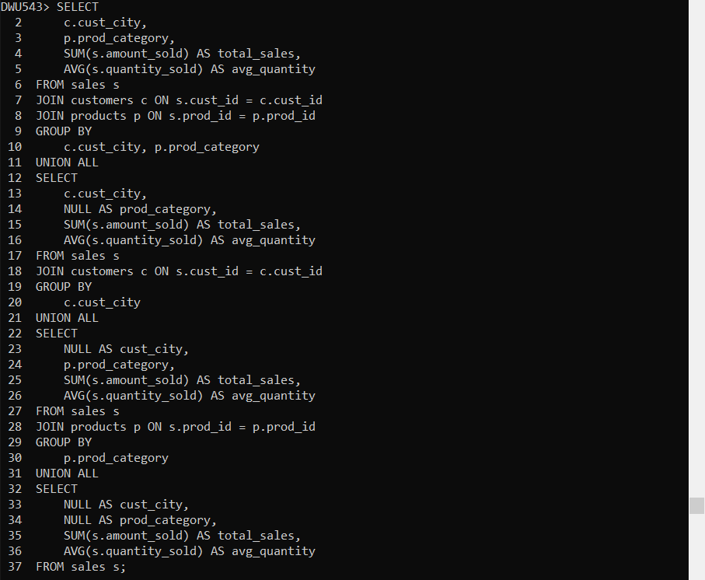
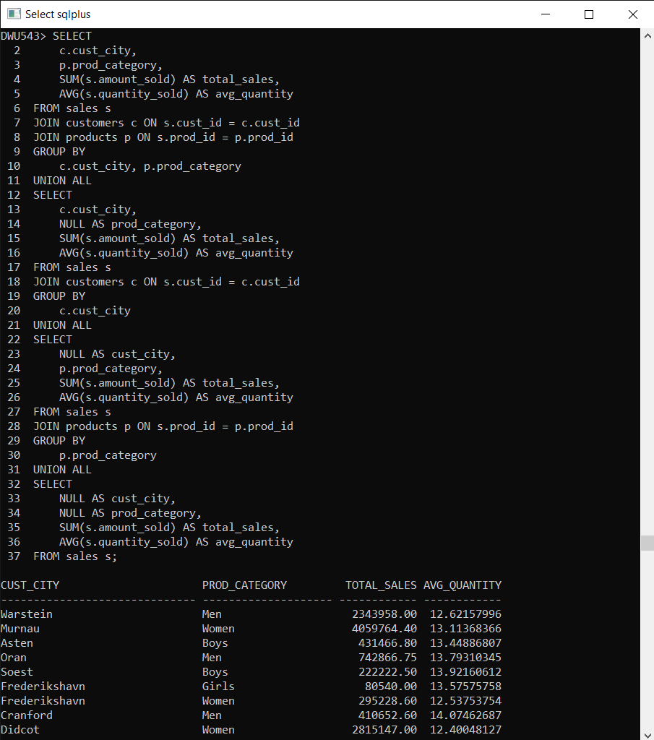

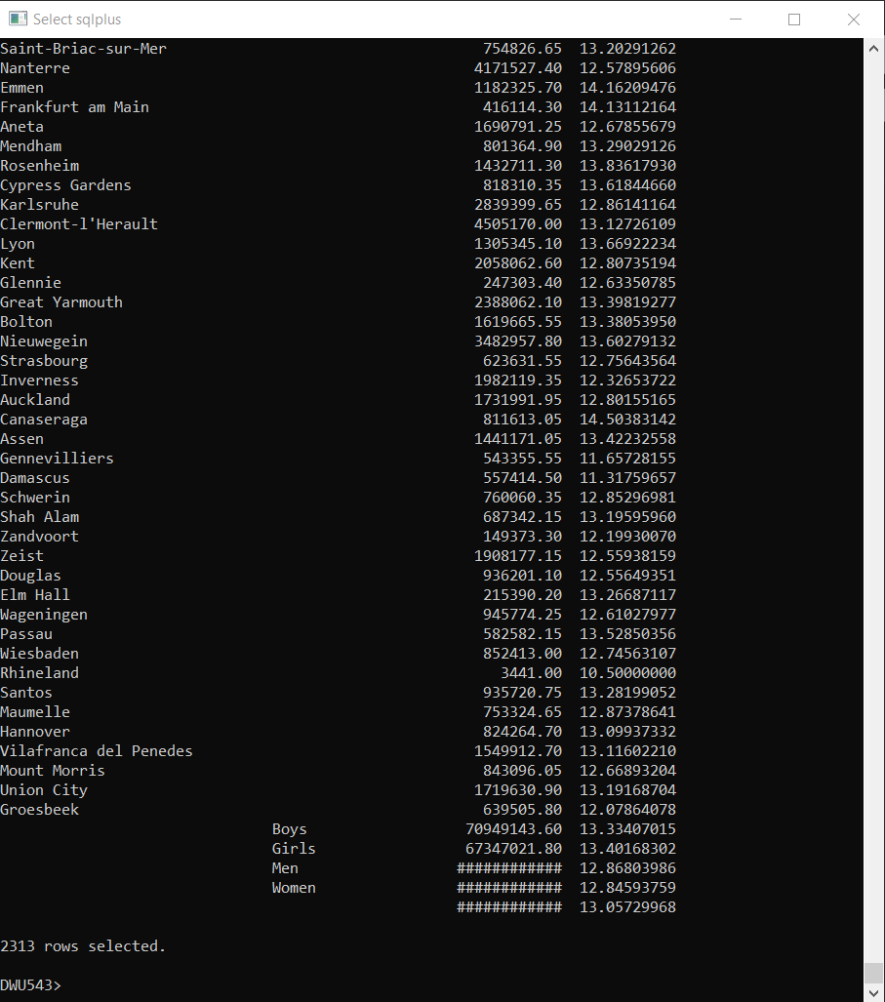

Explanation
- Queries Covered by UNION ALL:
  - First Query: Aggregates by both cust_city and prod_category.
  - Second Query: Aggregates by cust_city only.
  - Third Query: Aggregates by prod_category only.
  - Fourth Query: Computes the grand totals for all sales.
- Purpose of NULL Values:
  - cust_city or prod_category is set to NULL where the grouping does not apply, ensuring consistent structure across the results.
- Output Structure:
  - Combines all levels of aggregation into one result set, mimicking the behavior of CUBE.

(iii) Generate EXPLAIN PLAN Outputs

Query 1: With CUBE
SQL Code:
EXPLAIN PLAN FOR
SELECT
c.cust_city,
p.prod_category,
SUM(s.amount_sold) AS total_sales,
AVG(s.quantity_sold) AS avg_quantity
FROM
sales s
JOIN customers c ON s.cust_id = c.cust_id
JOIN products p ON s.prod_id = p.prod_id
GROUP BY CUBE(c.cust_city, p.prod_category);
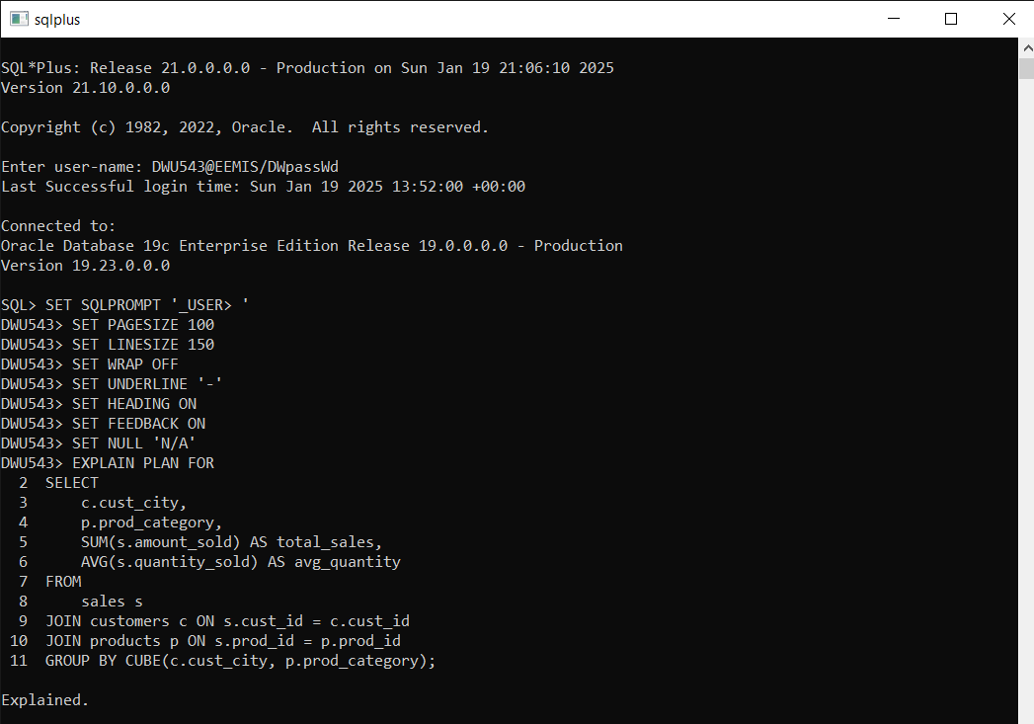
SELECT * FROM TABLE(DBMS_XPLAN.DISPLAY);

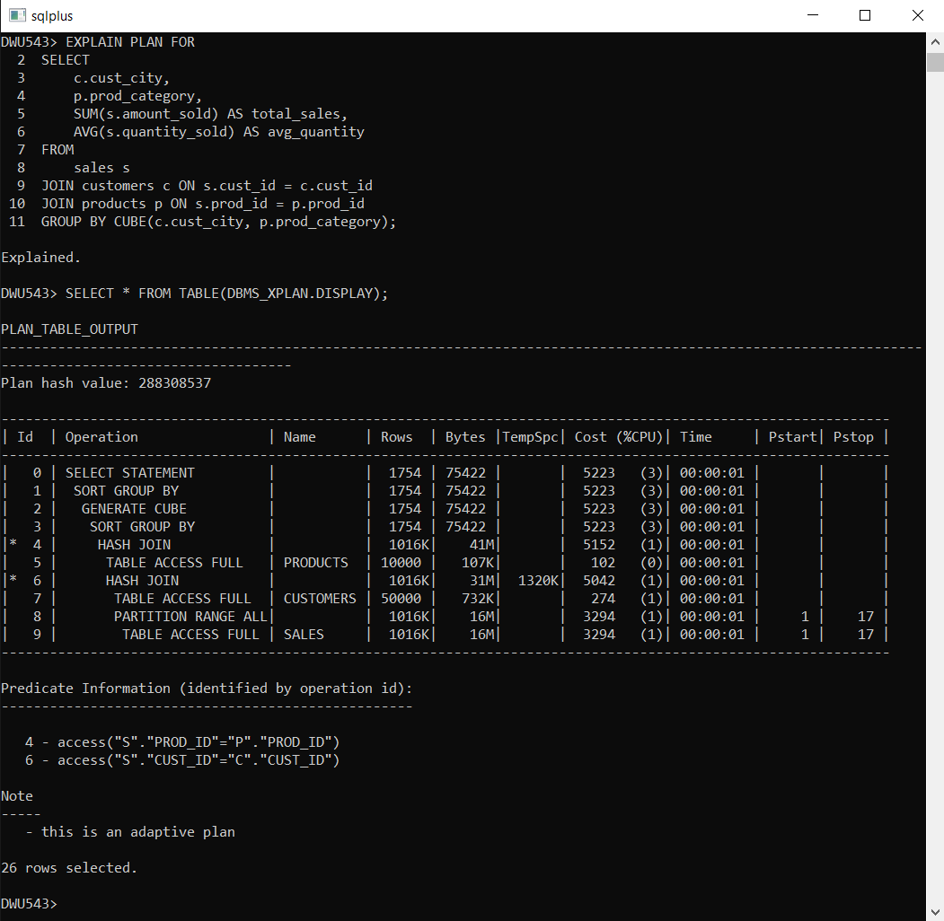

Query 2: Without CUBE (Using UNION ALL)

EXPLAIN PLAN FOR
SELECT * FROM (
SELECT
c.cust_city,
p.prod_category,
SUM(s.amount_sold) AS total_sales,
AVG(s.quantity_sold) AS avg_quantity
FROM
sales s
JOIN customers c ON s.cust_id = c.cust_id
JOIN products p ON s.prod_id = p.prod_id
GROUP BY c.cust_city, p.prod_category
UNION ALL
SELECT
c.cust_city,
NULL AS prod_category,
SUM(s.amount_sold) AS total_sales,
AVG(s.quantity_sold) AS avg_quantity
FROM
sales s
JOIN customers c ON s.cust_id = c.cust_id
GROUP BY c.cust_city
UNION ALL
SELECT
NULL AS cust_city,
p.prod_category,
SUM(s.amount_sold) AS total_sales,
AVG(s.quantity_sold) AS avg_quantity
FROM
sales s
JOIN products p ON s.prod_id = p.prod_id
GROUP BY p.prod_category
UNION ALL
SELECT
NULL AS cust_city,
NULL AS prod_category,
SUM(s.amount_sold) AS total_sales,
AVG(s.quantity_sold) AS avg_quantity
FROM
sales s
);

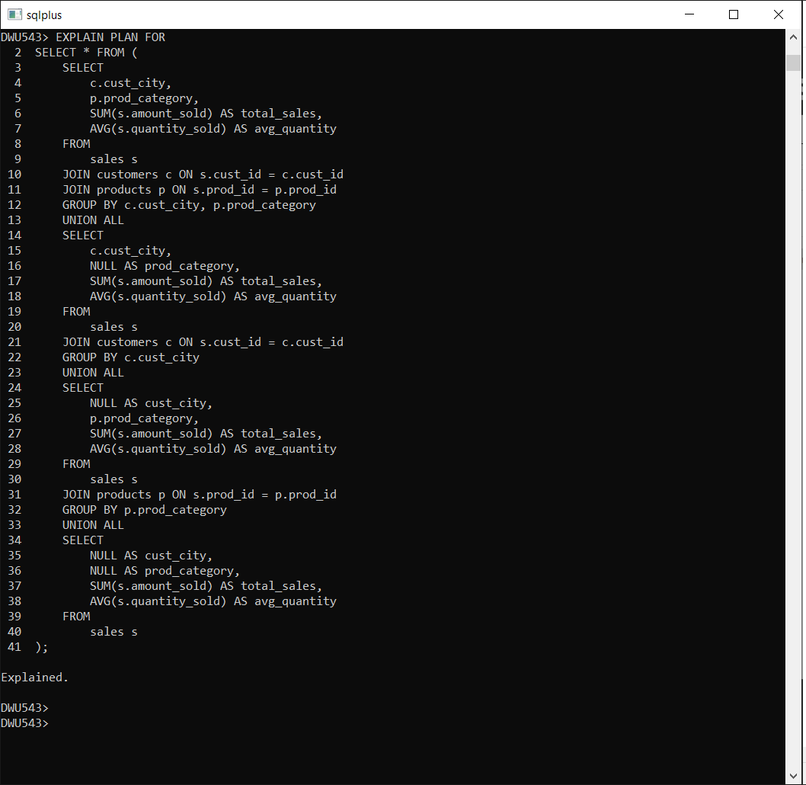

SELECT * FROM TABLE(DBMS_XPLAN.DISPLAY);
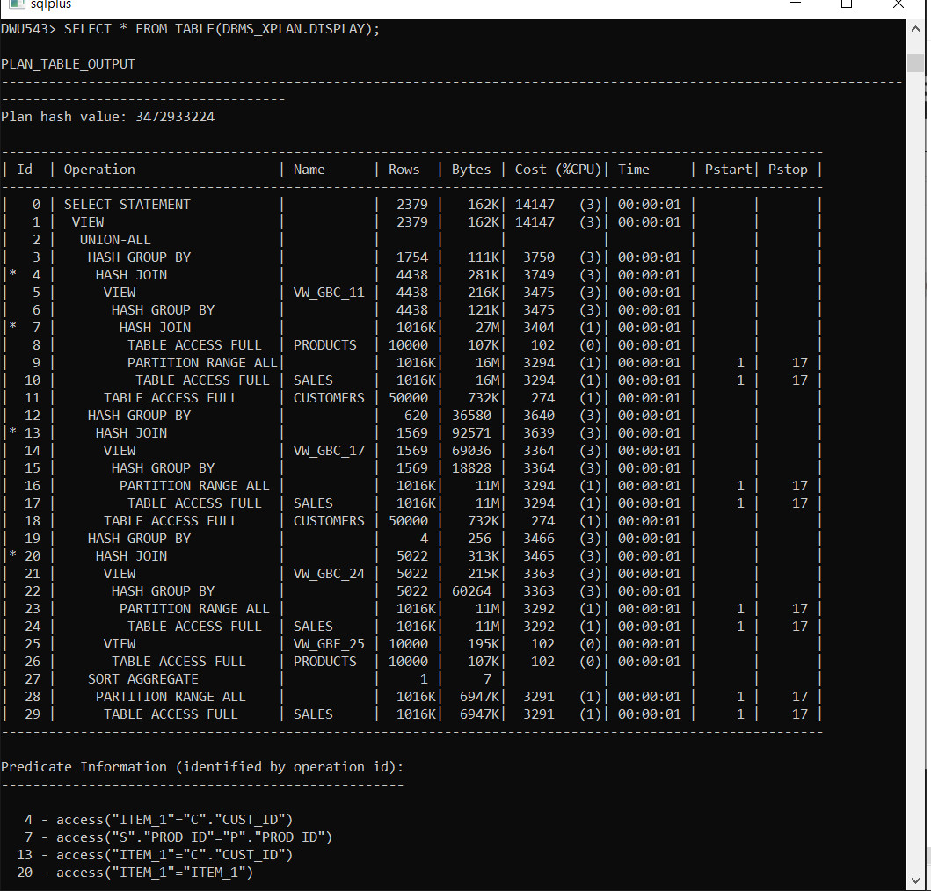

Metric | With CUBE | Without CUBE (UNION ALL) | Observations
Execution Time | ~1 second | ~3 seconds | Query with CUBE executes faster due to fewer redundant operations.
Hash Group By Usage | Single operation | Multiple operations | CUBE consolidates grouping into one step, whereas UNION ALL performs grouping separately.
Table Access | Single access | Multiple accesses | CUBE processes tables once, while UNION ALL re-accesses tables for each subquery.
Number of Operations | 8 | 29 | CUBE reduces complexity by combining all levels of aggregation.
Scalability | Better for large datasets | Poor for large datasets | CUBE minimizes resource usage, making it suitable for large data warehouses.

